Single-run measurement using ALV multicorrelator and Harvest.xlsx

Screen looks something like this to start. The center of the screen (circled in red) contains most of what you need.

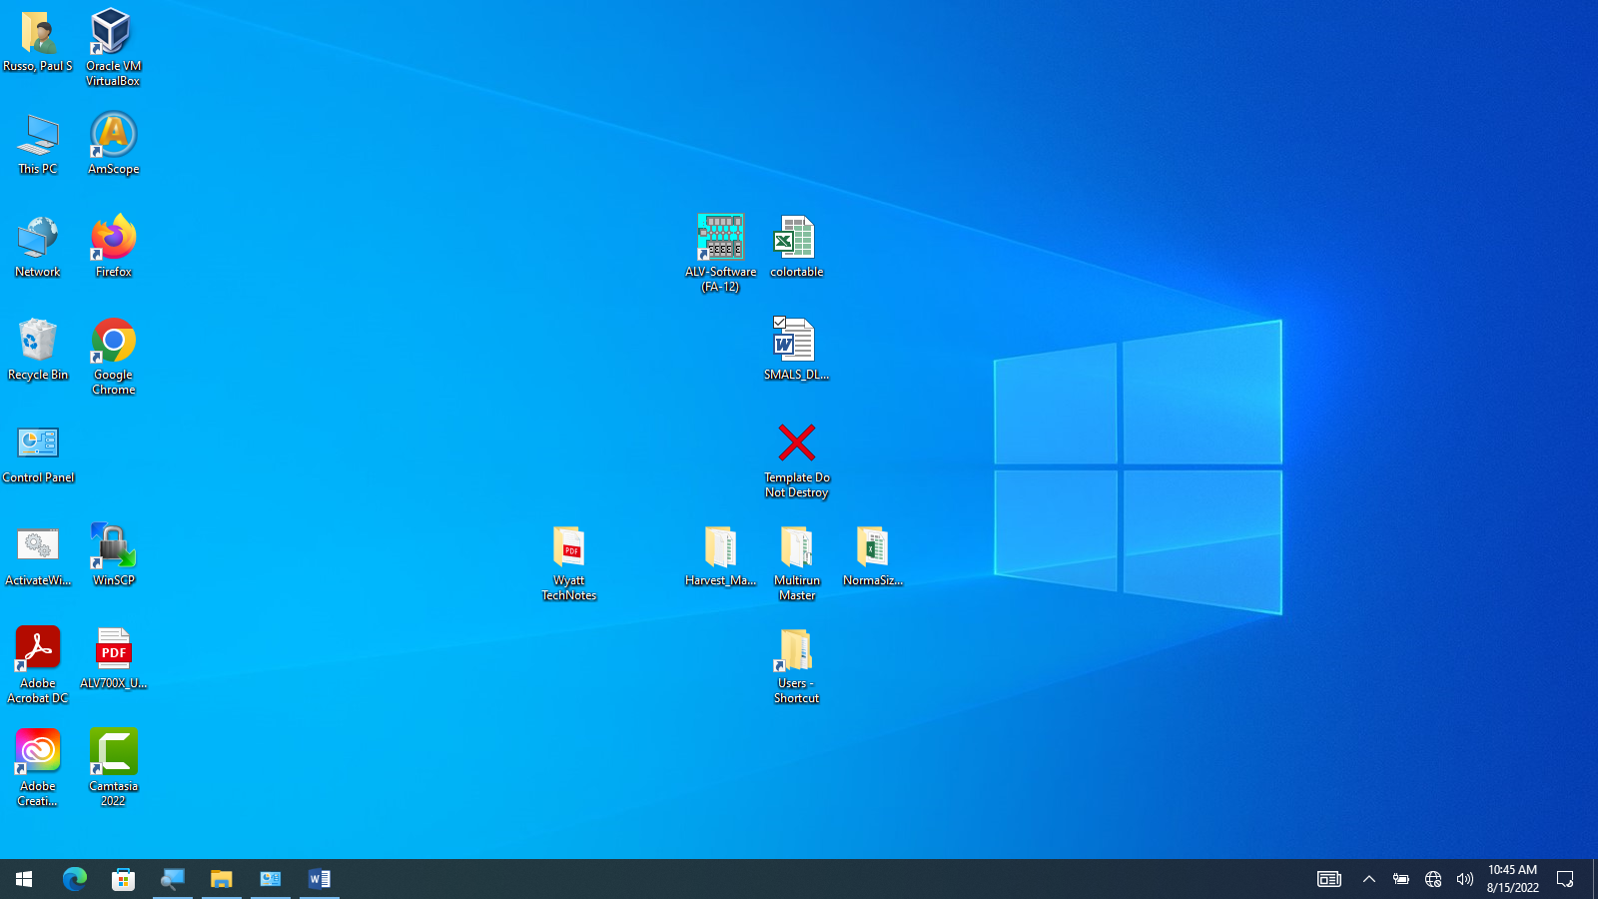



Navigate to Users directory and make a directory for yourself, if one does not already exist.

Make a folder to contain data.

Copy contents of Harvest_Master Folder on desktop to your new directory.

Should look something like this:

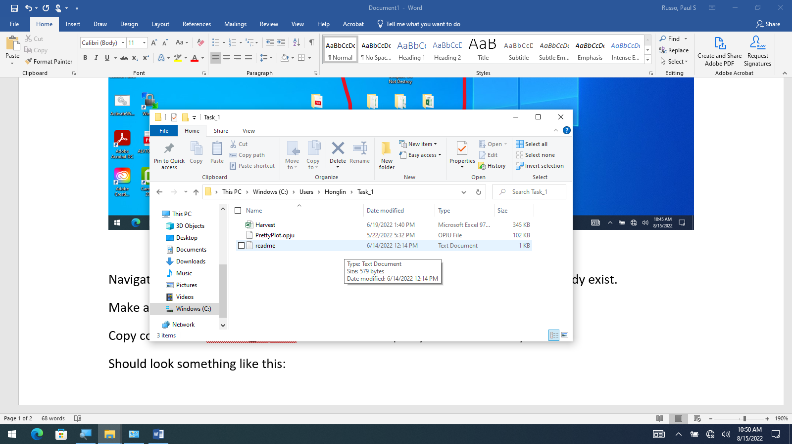

Now you will mostly run the SMALS_DLS_SOP on the desktop. For convenience, it is copied here but the background screen may look somewhat different.

click alv-software (FA-12) shortcut

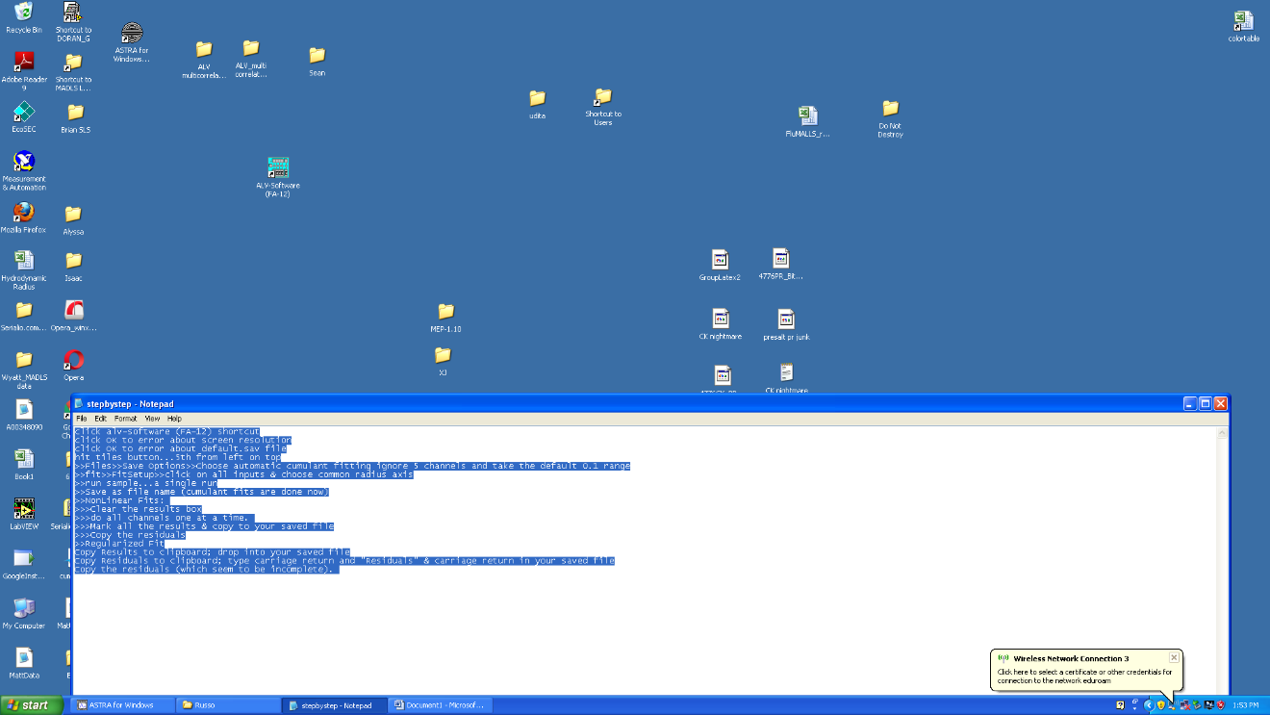



click OK to error about screen resolution, if it appears.

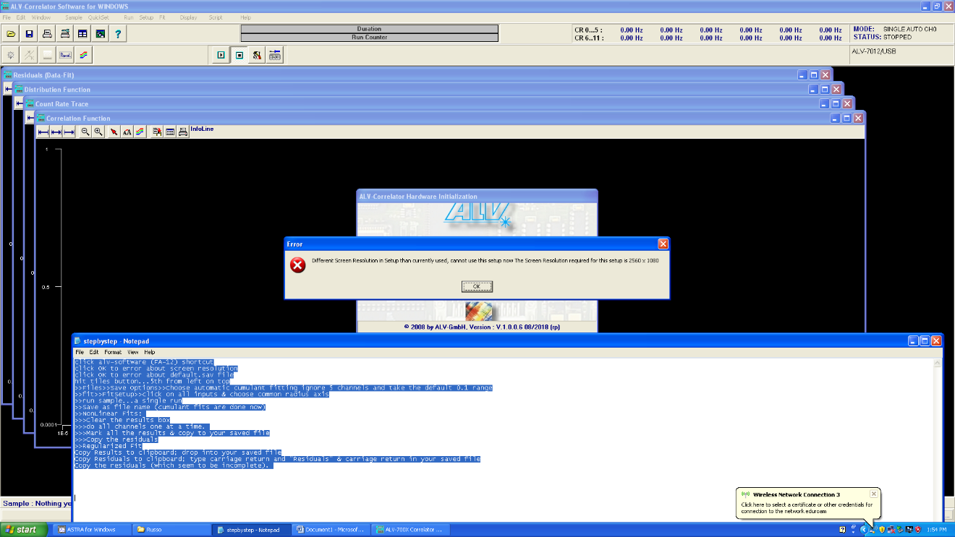



click OK to error about default.sav file, if it appears.

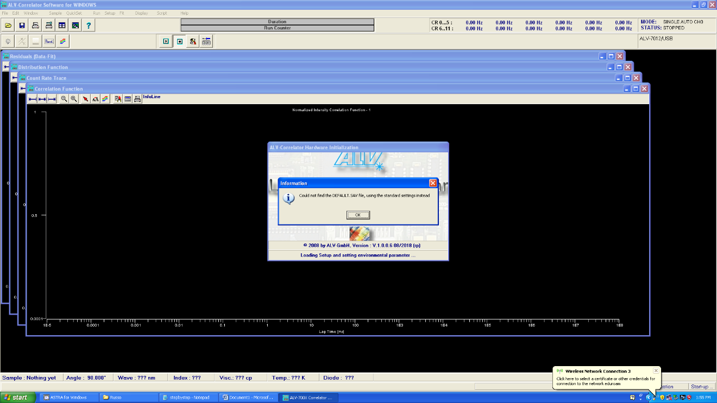



hit tiles button...5th from left on top

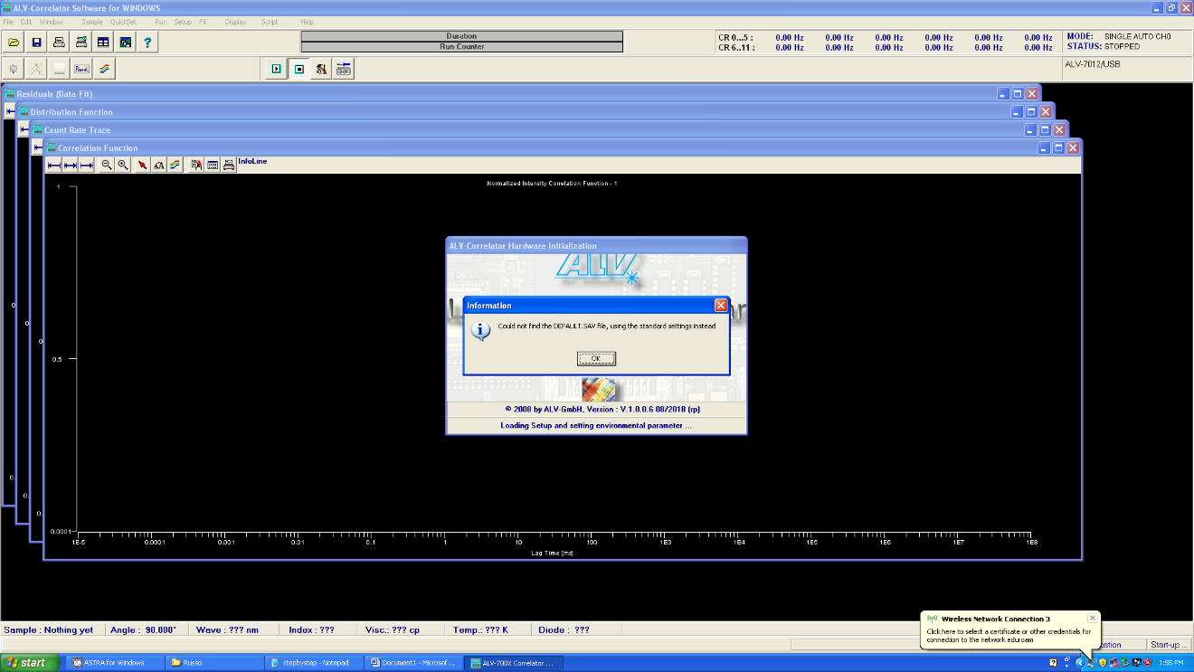



>>Files>>Save Options>>Choose automatic cumulant fitting ignore 5 channels and take the default 0.1 range

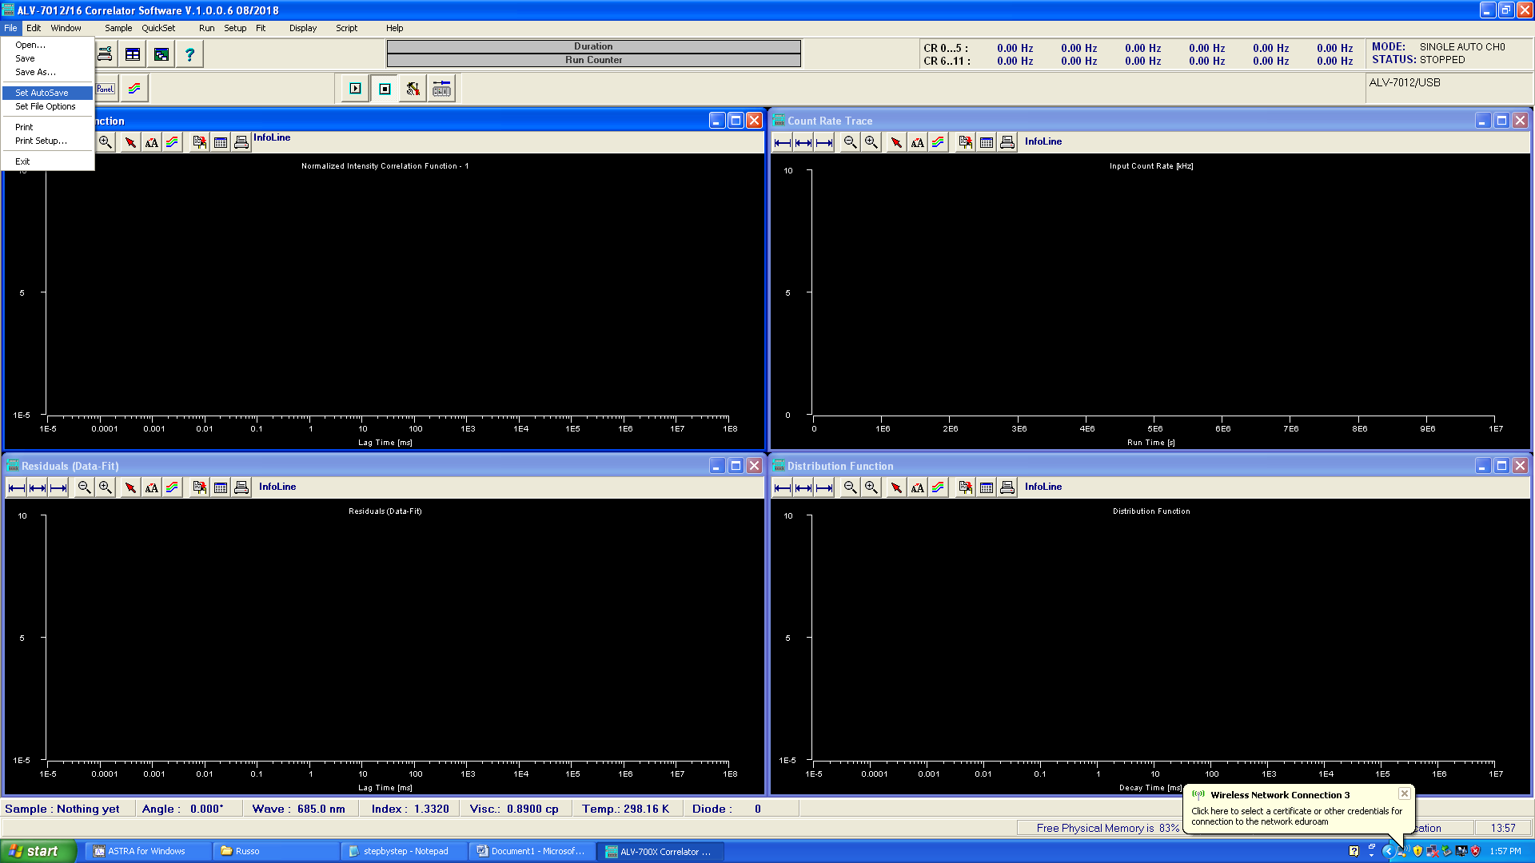



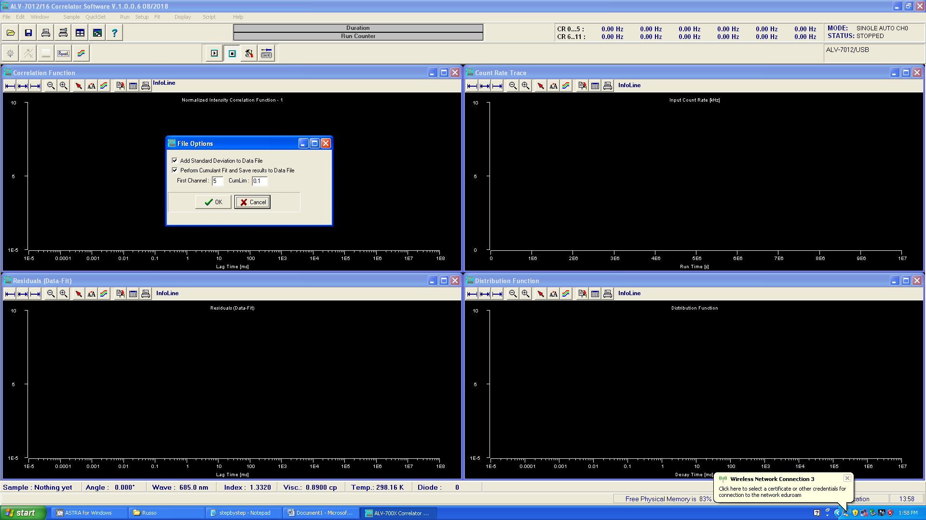



>>fit>>FitSetup>>click on all inputs & choose common radius axis

>>Click Done

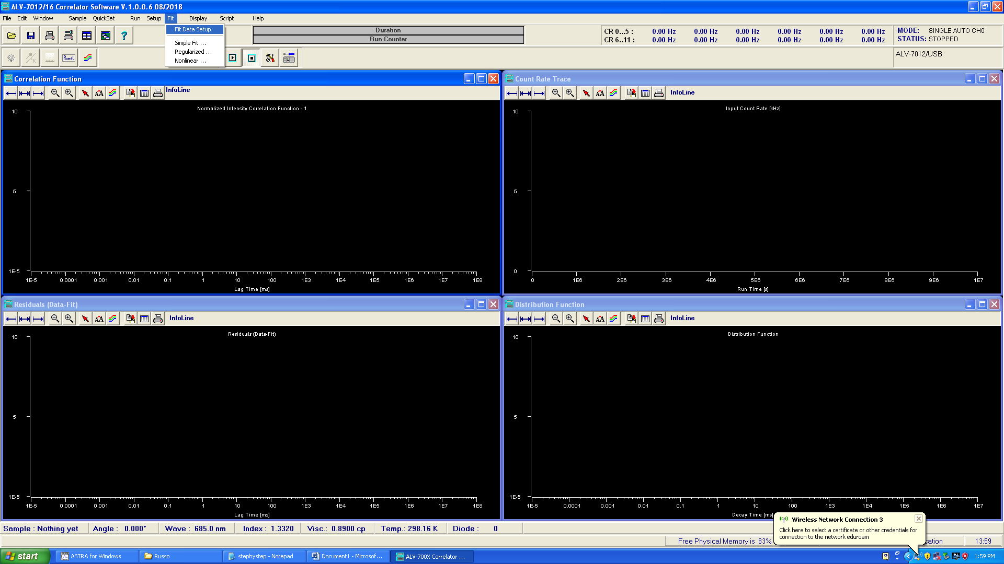



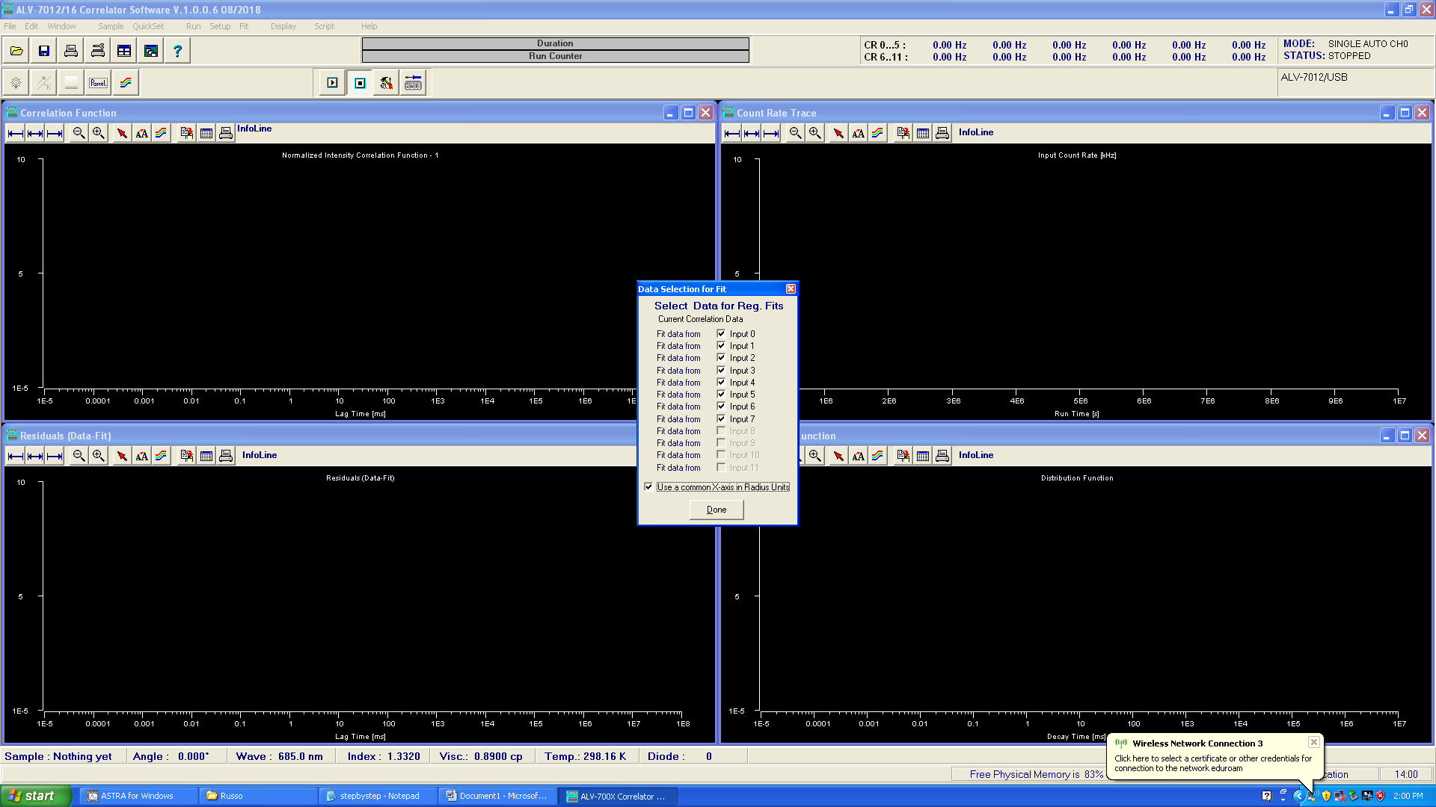



>>run sample...a single run.

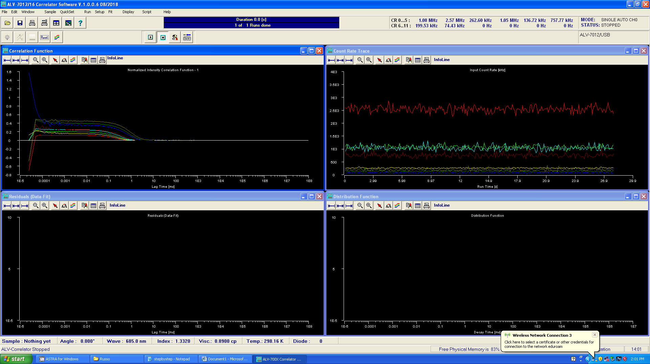



Click Zoom (Magnifying Glass + ) to eliminate low-lagtime channels.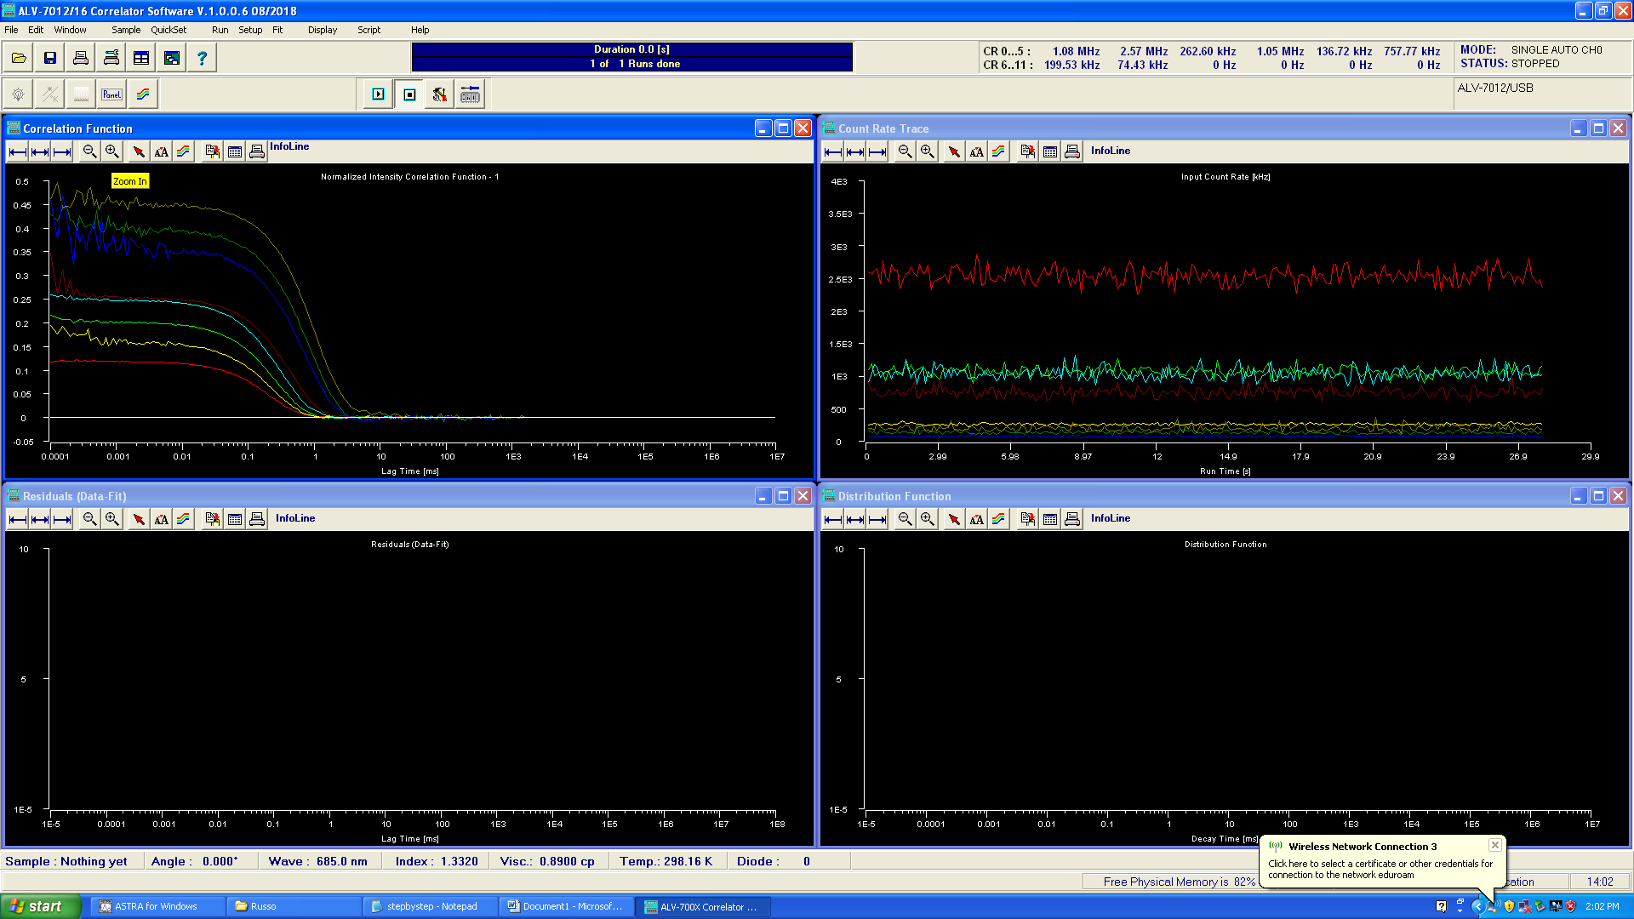



>>Save as file name (cumulant fits are done by the program now and stored with the file)

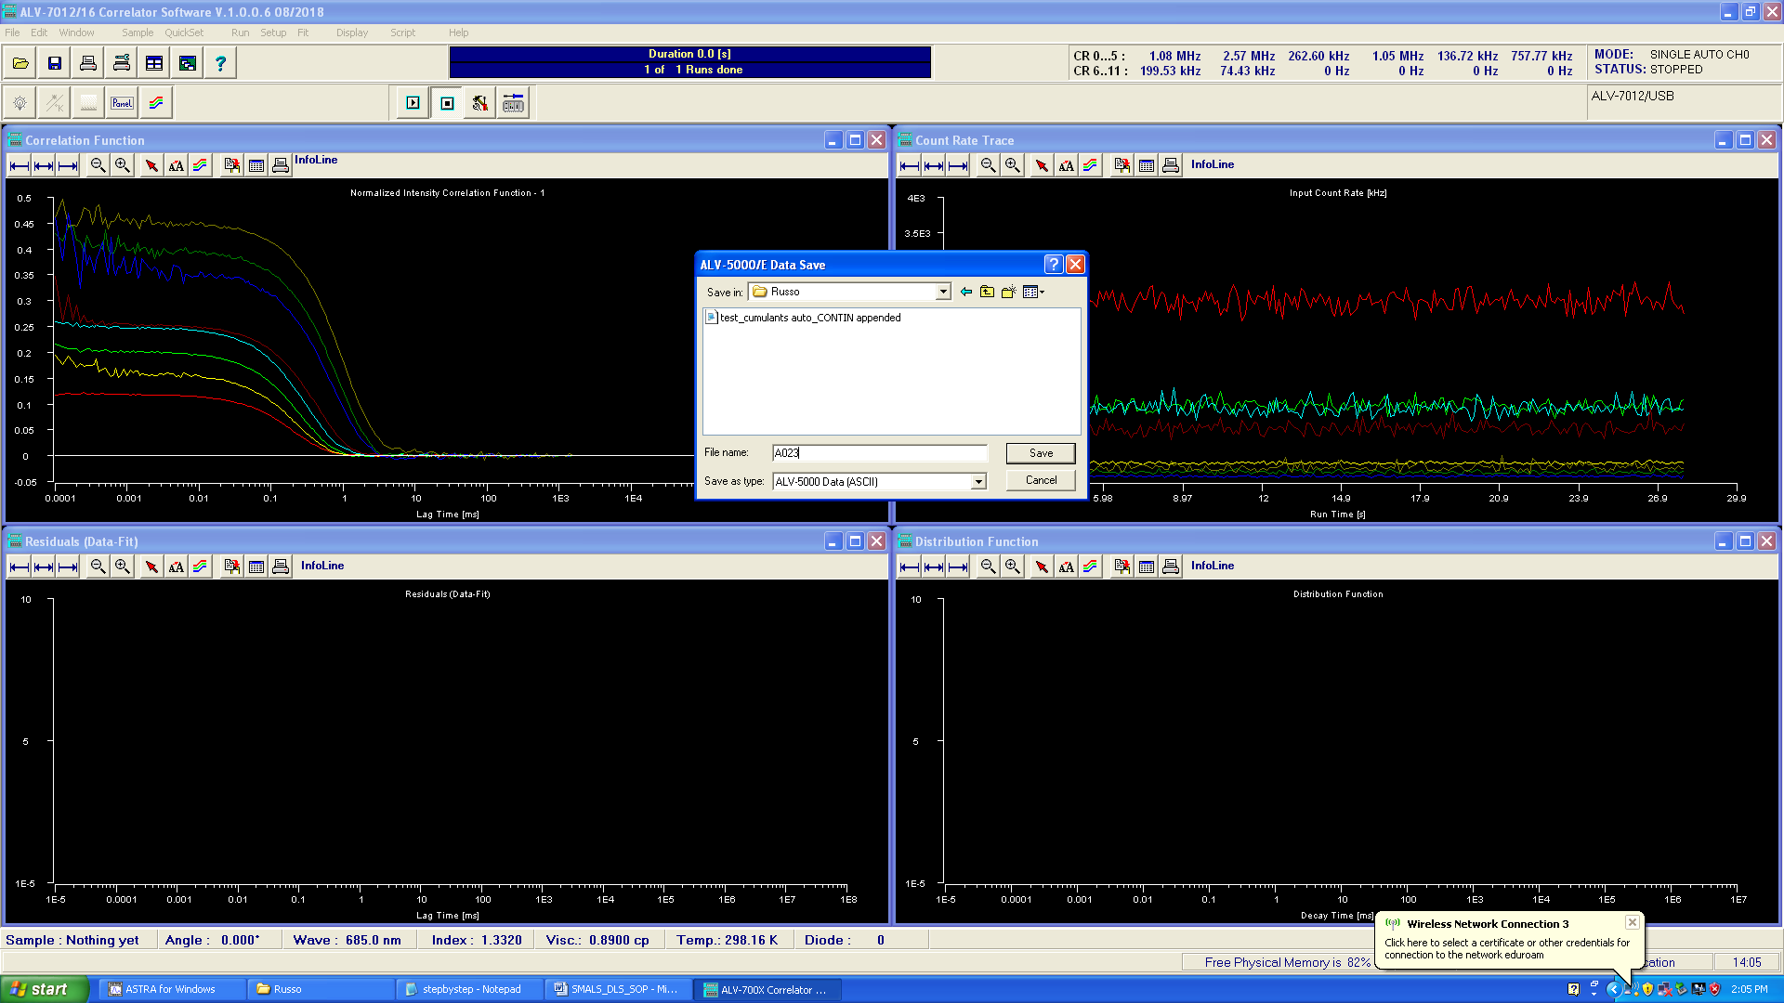

The ALV_DLS_SOP Continues with more information, but we stop here to use Harvest.

To use Harvest, create a directory with the Harvest.xlsx, PrettyPlot.opj and Readme files. These can be found on the desktop in the folder Harvest_Master. In this case, we told the ALV to save the file here:



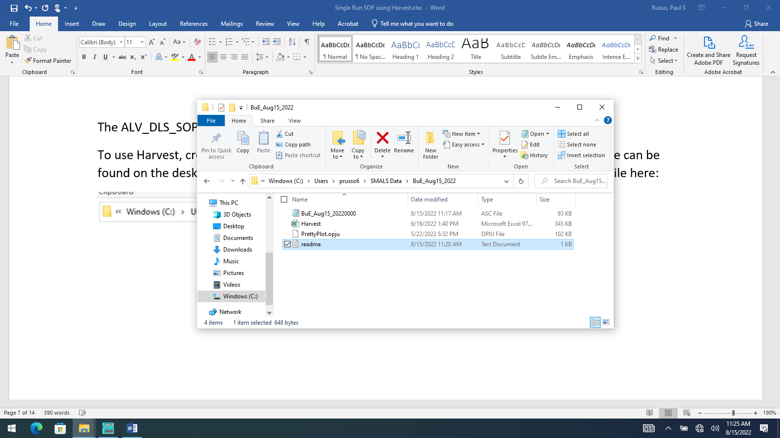

Launch Harvest.xlsx and click Enable Content

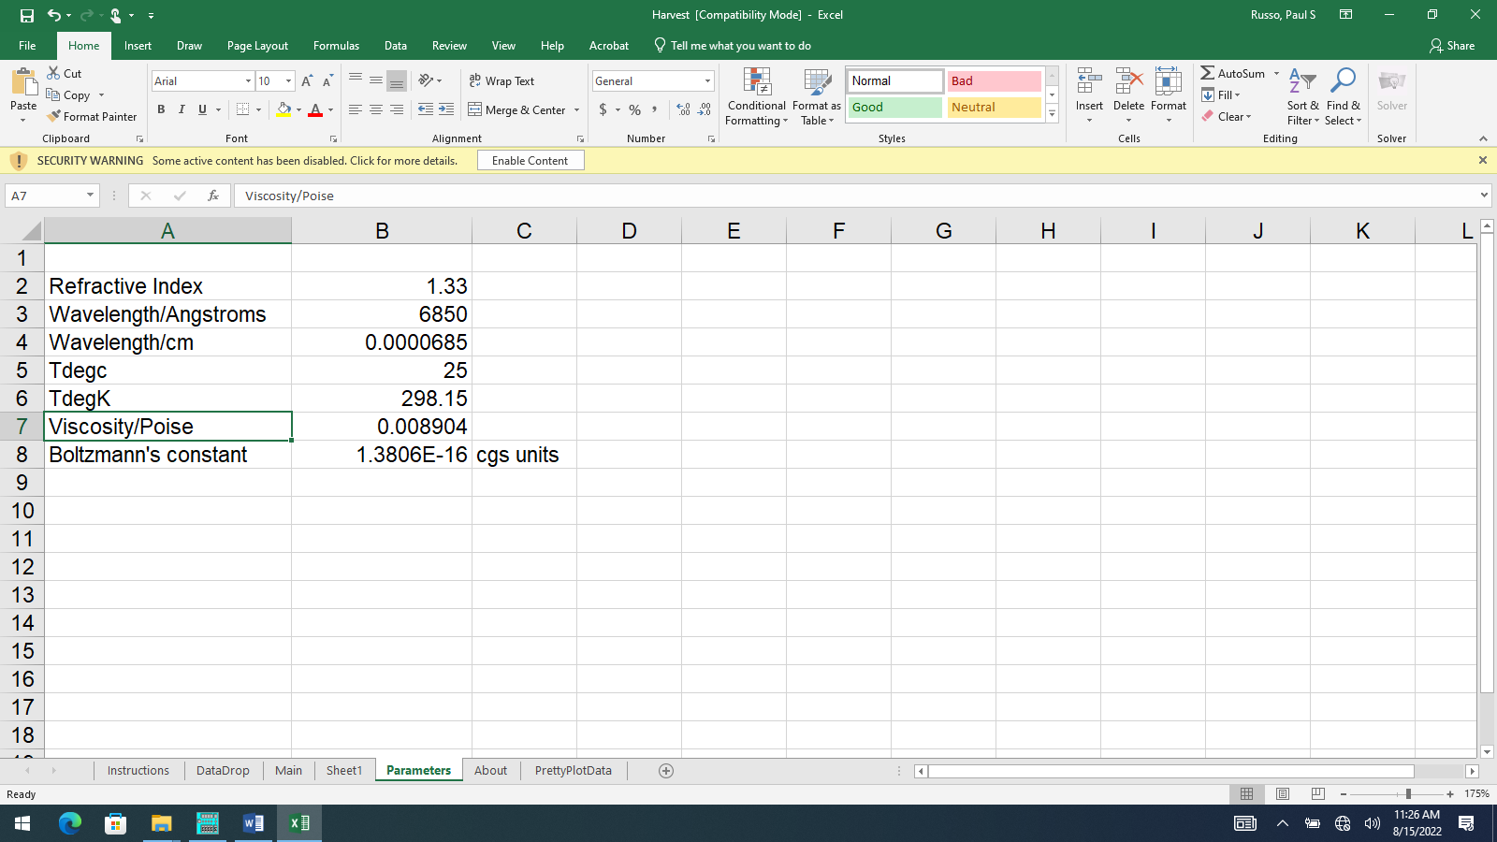



Click the Parameters tab, set your parameters appropriately. The ones above are OK for this sample.

Click the Main tab (unless you want to read instructions first).

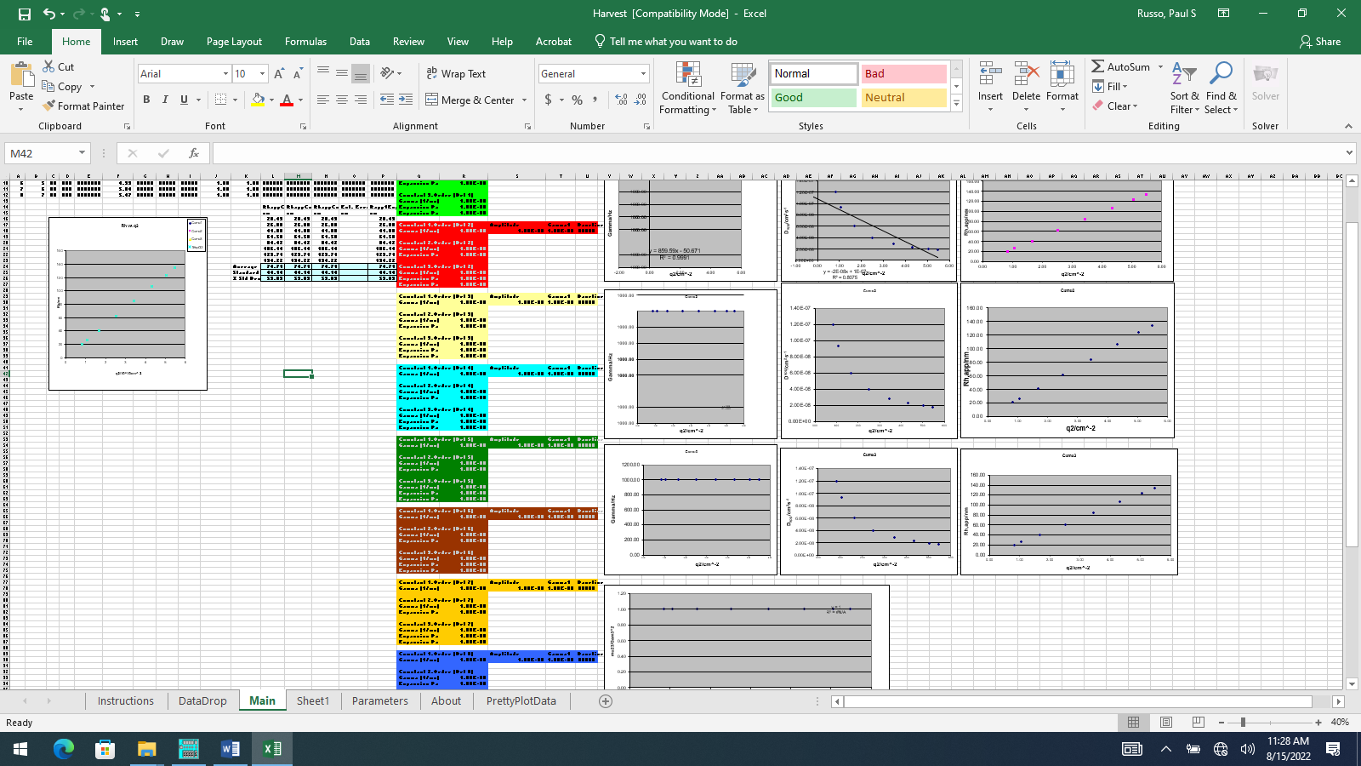



This tab shows the plots you will populate by using Harvest. Right now, it’s way too much information. So, expand using the slider at lower right.

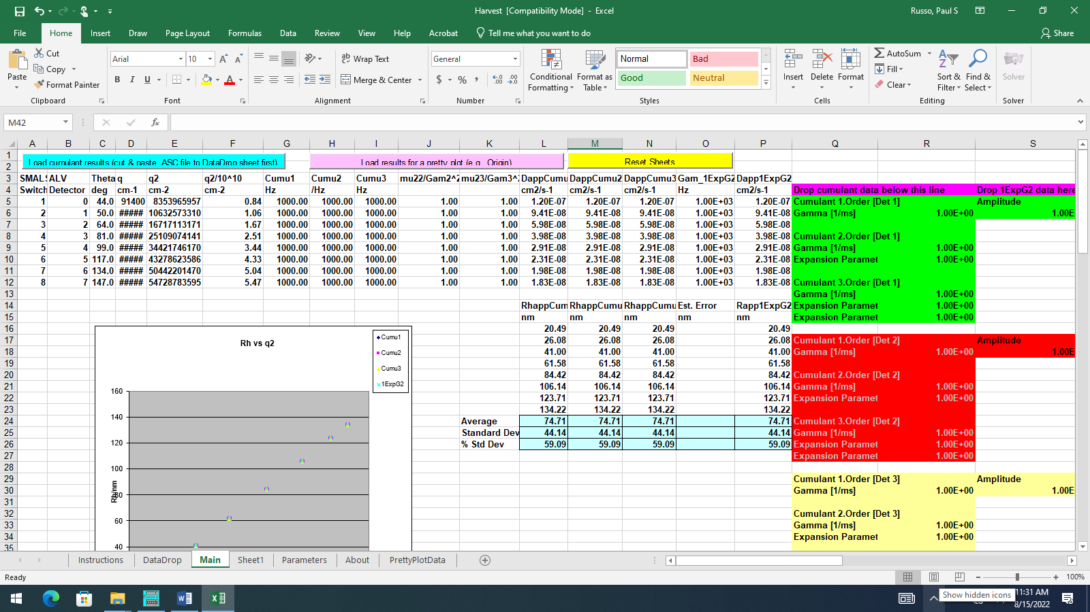

This is how the screen looks for an fresh copy of Harvest. If yours does NOT look like this, you can click the Yellow Reset Sheets button. That will refresh the screen (maybe after a few warnings…ignore them).

The next step is to navigate to your data directory and open your .ASC file (in this case, BuE_Aug15_20220000.ASC) in Notepad.

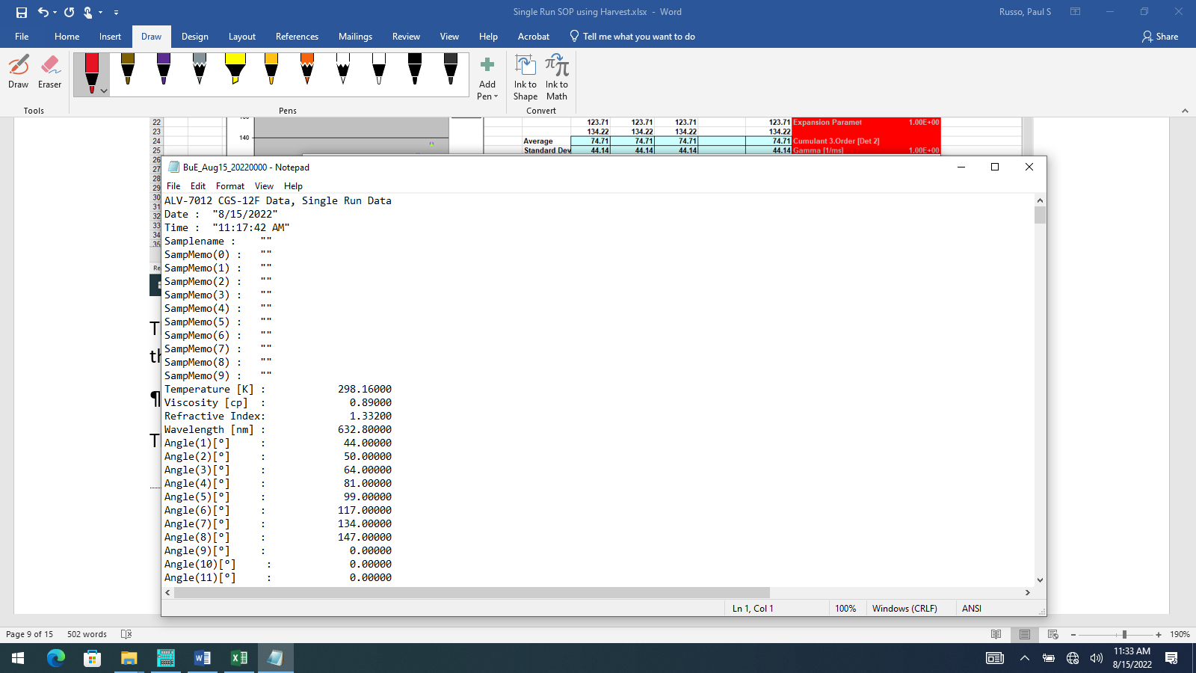

Hit Ctrl-A to select all text. Notepad jumps to the bottom, where you can verify that cumulant data was stored.

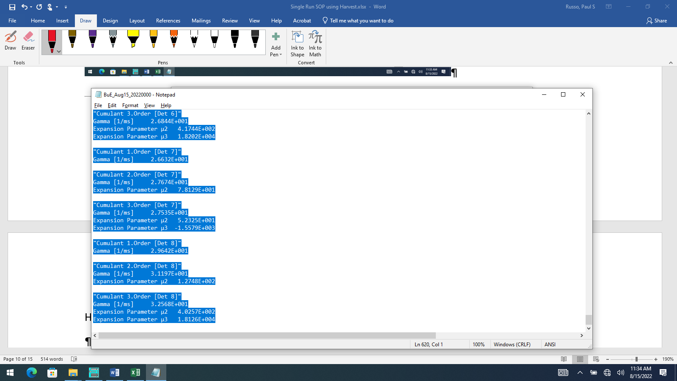

Type Ctrl-C to copy

Navigate back to Harvest

Click DataDrop tab. (If this sheet is not empty, return to Main and click yellow Reset Sheets button)

Note the light green cell A2

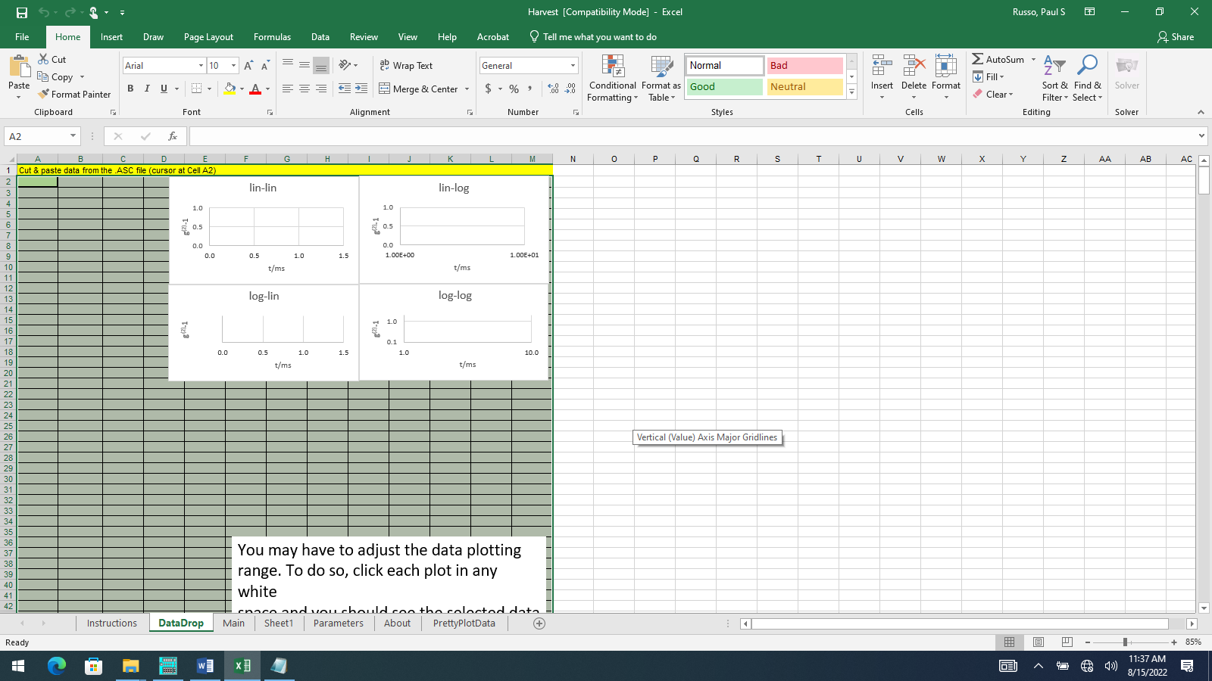



Ctrl-V to copy clipboard into A2

You should see plots in the 4 different representations. In principle, you have seen these on the ALV screen already, but this is a reminder. You can adjust them for appearance and try to decide if any channels are bad (in the plot below, the red channel is noisy at low times, which is a detector flaw).

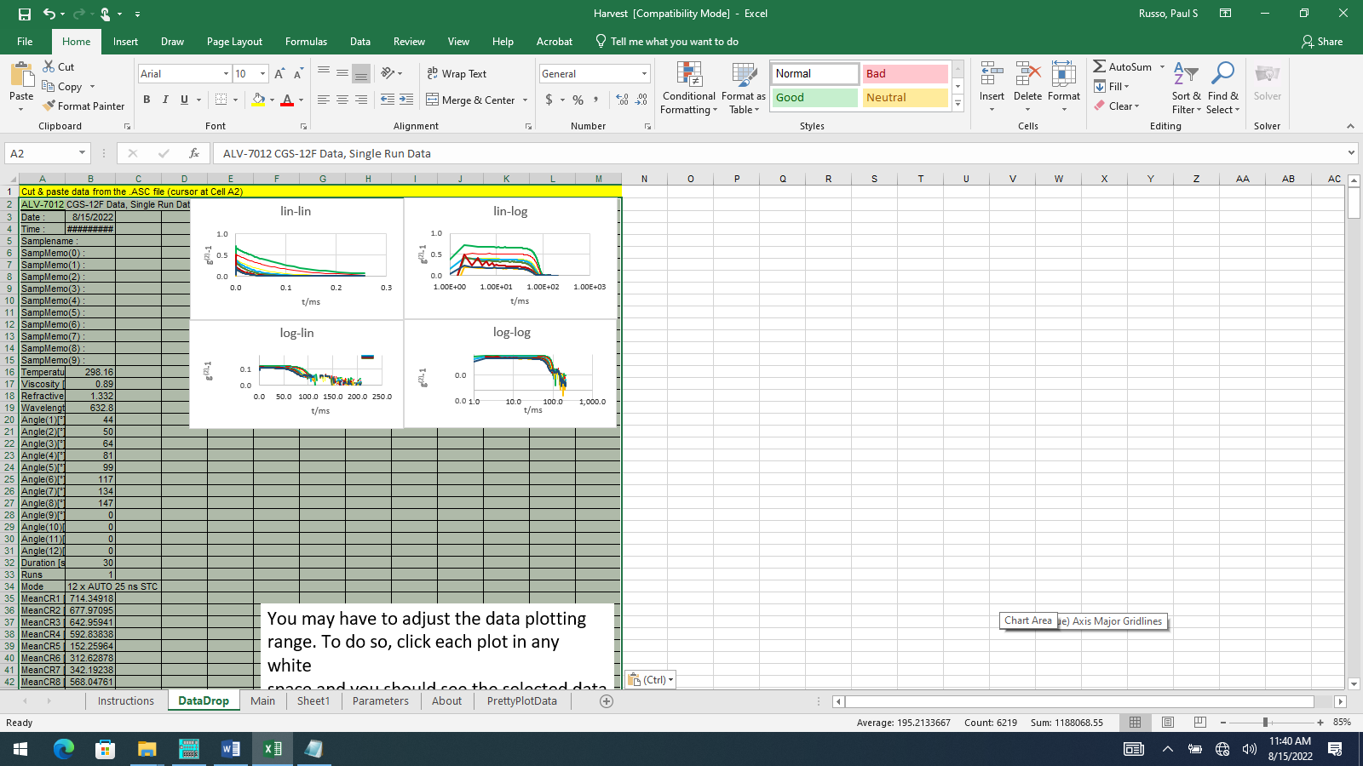

Also, in the plot below, note that the log-lin (semilog) plot looks weird. That is because the routine went too deep into the file and started picking up the uncertainty data. This throws off the autoscaling. See the warning note and rescale appropriately (it’s best to expand the plot). This has been done below.

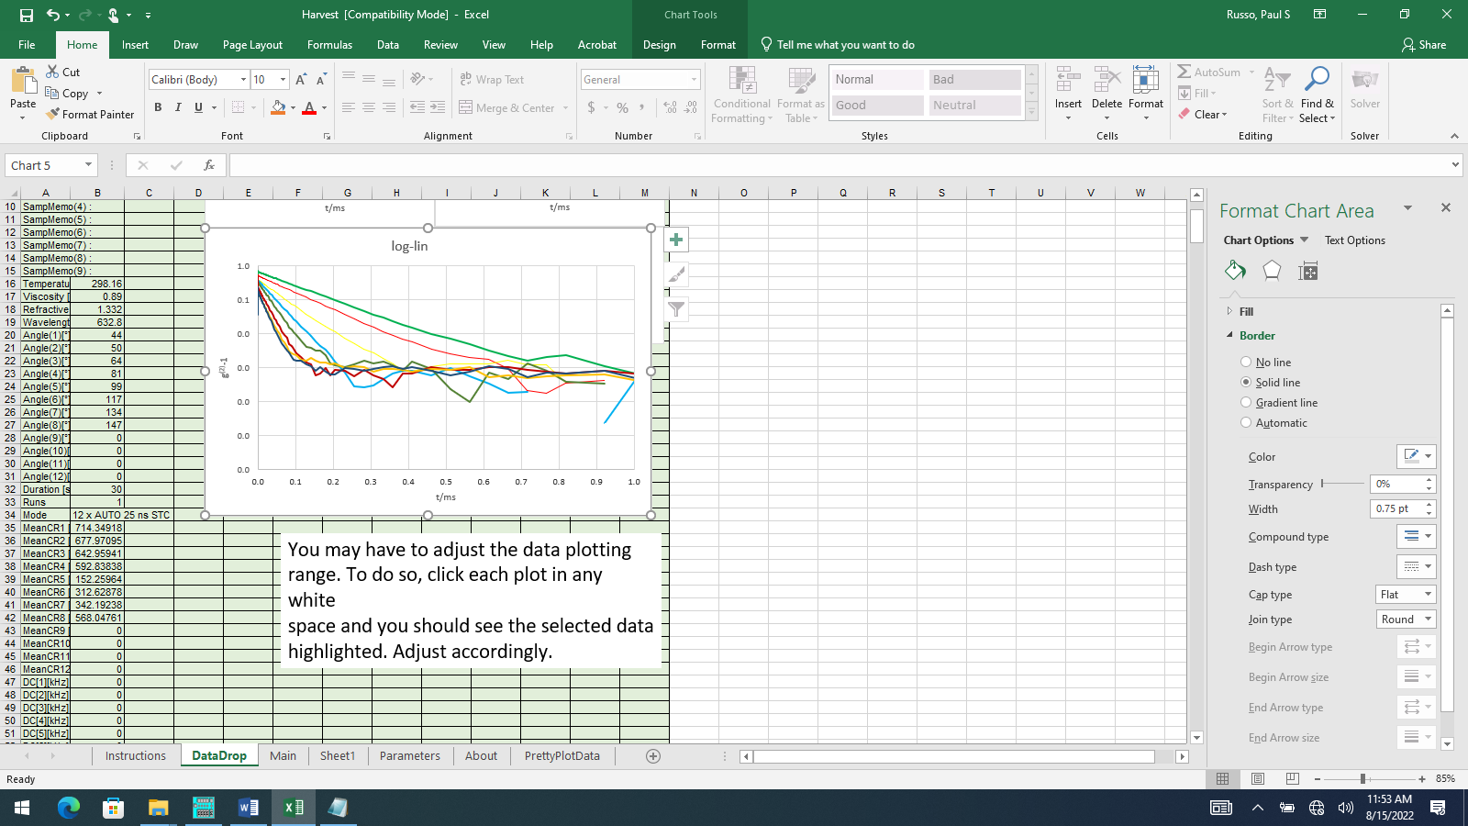

In this case, the flattening at long lag times indicates some kind of baseline uncertainty, possibly caused by dust strikes or laser drift. It indicates we should perform the nonlinear 1EXP floating baseline analysis, as well as harvesting the results from the ALV’s linear cumulants fits, already present for first, second and third-order. The need to do a nonlinear fit should have been obvious from the ALV screen, if we were paying close attention.

Click back to the Main sheet and click the Cyan button at the top left. This will load the cumulants data and build  vs. q2 plots for each cumulant type. It will also plot 2/2 plots. You will have to scroll to see it all, but here’s the overall view.

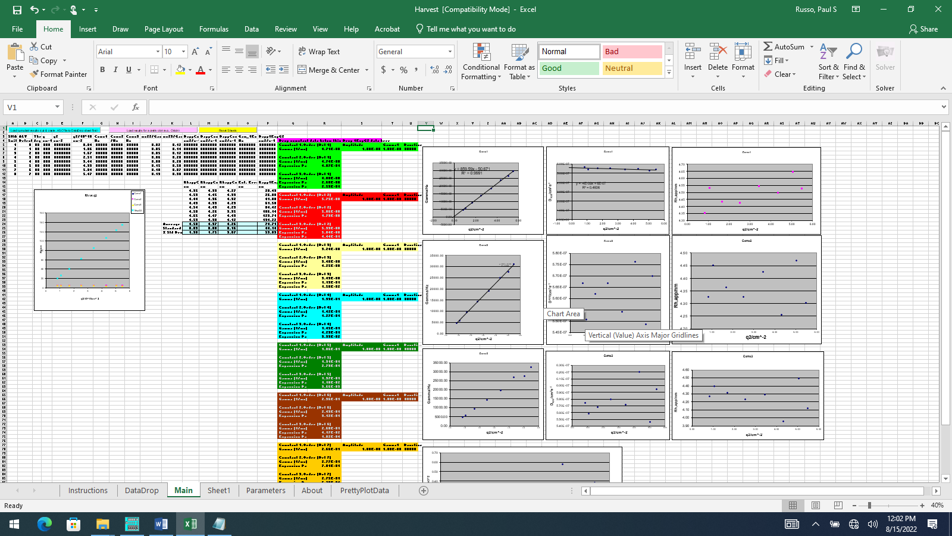

You can scroll left and right, check 1st, 2nd, and 3rd-order cumulants fits. Check the 2/2 plots for trend, etc. Next, alt-Tab to get to the ALV screen again. Select fits🡪nonlinear. By default, it does a single-exponential fit with a floating baseline. Each channel must be measured separately. ALV channels are numbered 0-7, corresponding to 1-8 in our software.

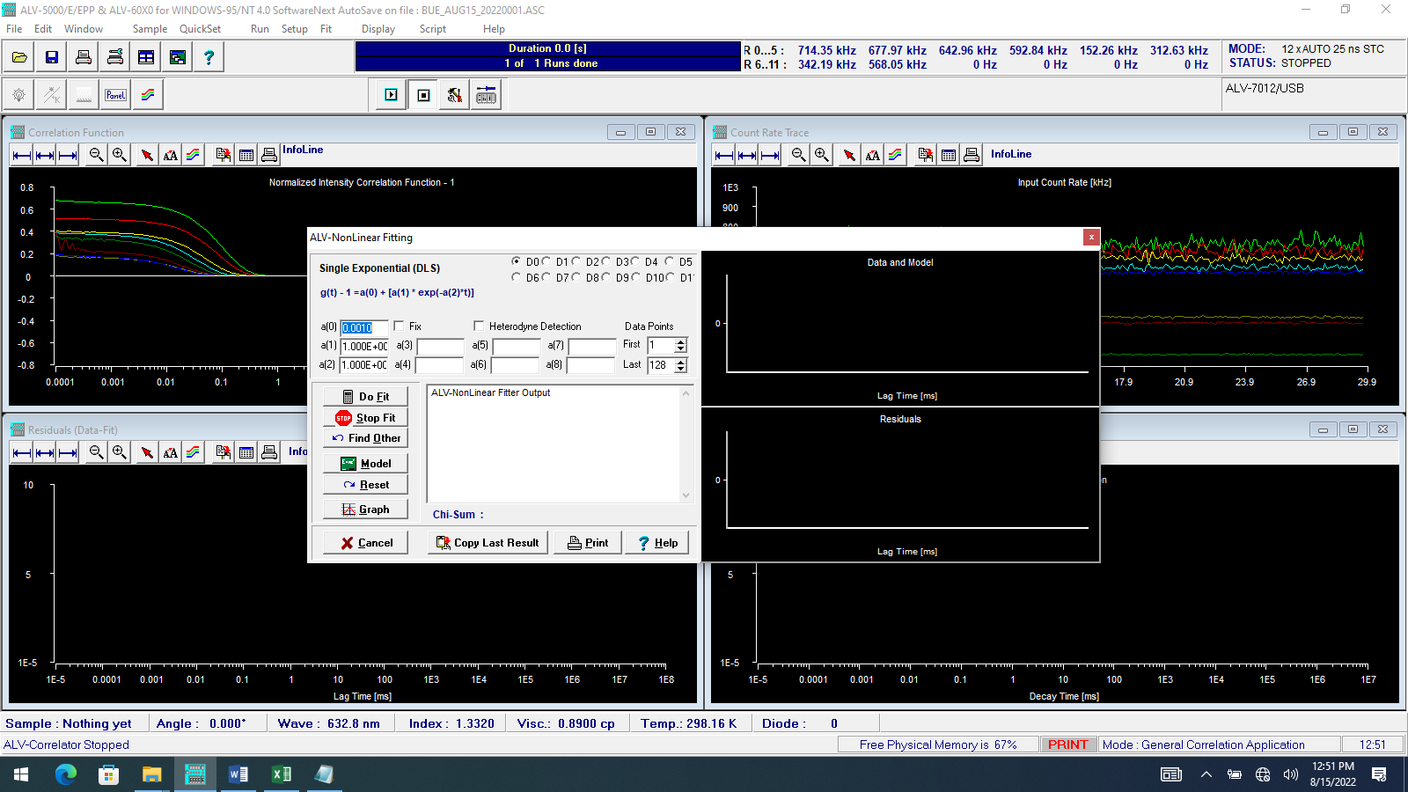

Set the number of channels appropriately. Usually, the first channel should be >5. The last channel used is not as important in nonlinear fitting because the baseline is adjusted to match. You can use the ALV cursor keys to figure out which channels to use, though.

Press the Do Fit button for channel d0. To get the cursor, right click on a plot and select “show cursor”. Use left-right arrows and page keys. The cursor may not be visible at first, tucked away on the left side of the plot.

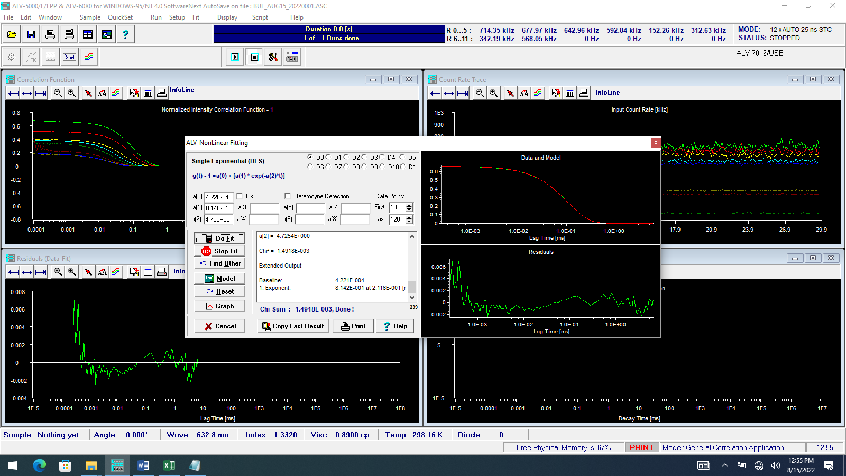



Inspect the residuals. This is not amazing performance; probably the sample should be filtered or freshened by heating/cooling.

Press Copy Last Result button.

Alt-Tab back to Harvest.

Past in the appropriate cells for detector 1 (Cell S1, coded green, same as the ALV color choices).

Alt-Tab back to ALV. Select detector d1. Press Do Fit. Cut-and-paste to Harvest in detector 2 (Cell s17, red)

Repeat for the remaining channels.

The data will be plotted, and a summary of results prepared:

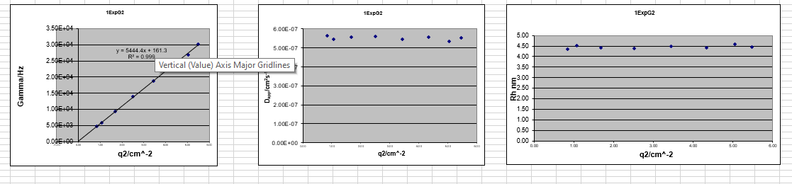

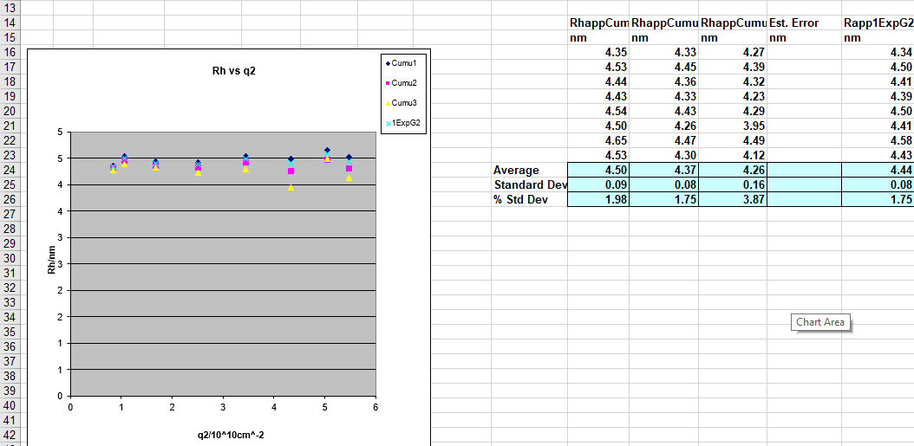

These data suggest a fairly uniform “particle” for the Brij-97 microemulsion, with hydrodynamic radius of about 4.5 nm, assuming the viscosity is that of water. The rising 2/2 value (see below) is even worse if the 2/2 values from 3rd cumulants are used. Third cumulants is the default (this plot was altered by re-selecting the data). This is probably a dataset that would benefit from the nonlinear cumulants approach in our Multirun.xlsx software.

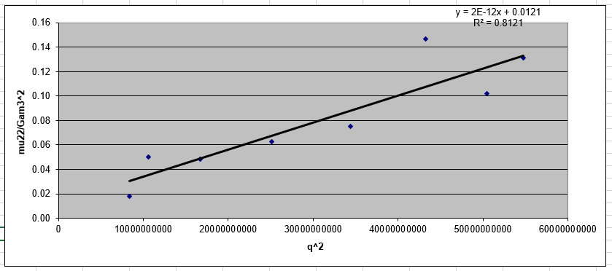

Finally, export the data to a spreadsheet that can be dropped into Origin or other high-quality graphing program by pressing the pink button.

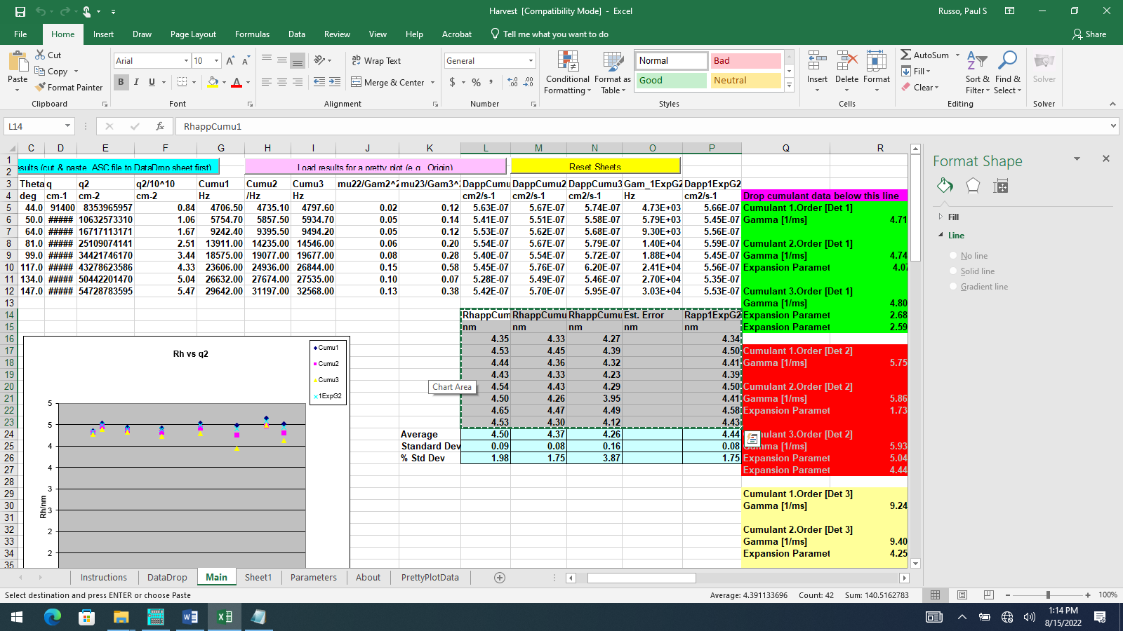

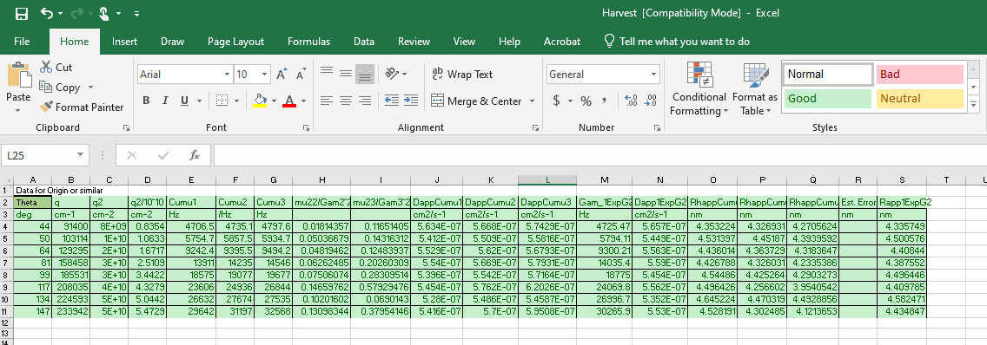

Finally, you will launch PrettyPlot.opj in Origin and drop in these data. Launch Origin by double clicking PrettyPlot.opj. Select Window🡪Tile Horizontally. Your file may look like this one (if not empty).

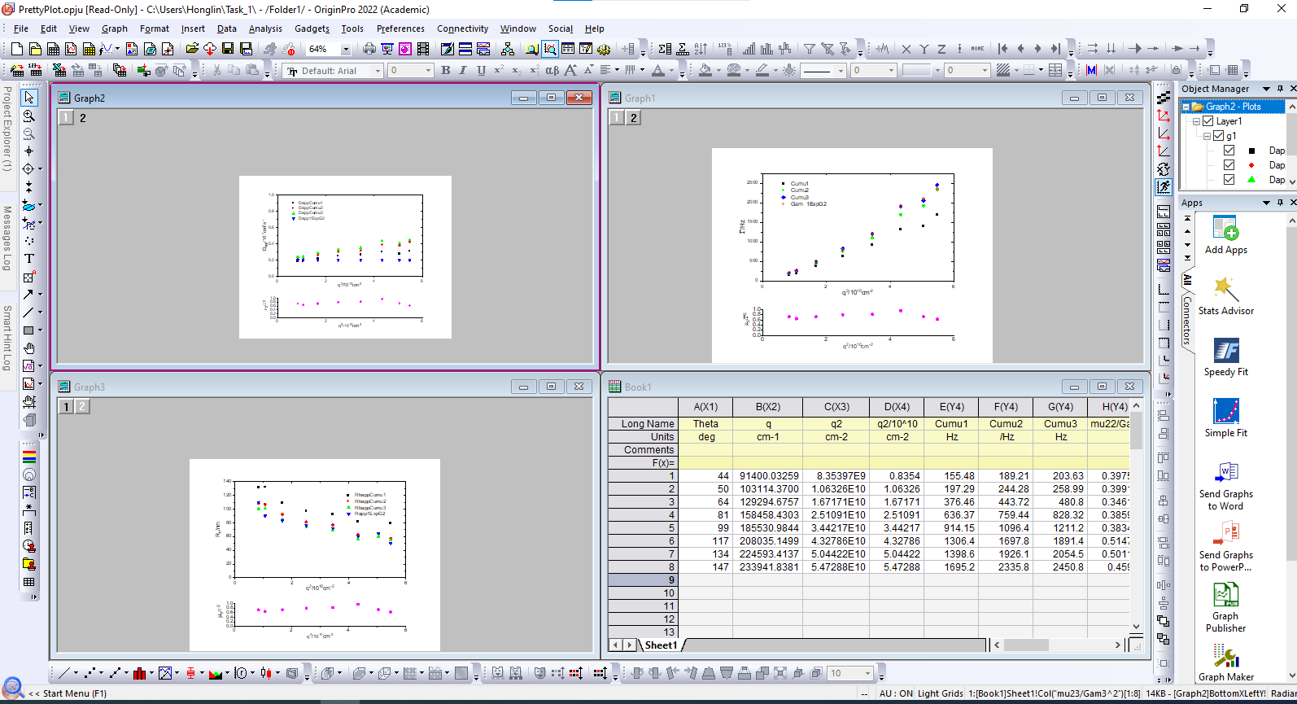

Cut & paste from Excel PrettyPlot spreadsheet to the Origin workbook. You may find the headings pre-populated. If not, drop the first two rows from Excel to Origin to the top two (metadata) rows. Then drop the 8 rows of data from Excel to Origin’s top row of real data.

You may observe that some plots seem blank. This means the y-axis has to be rescaled.

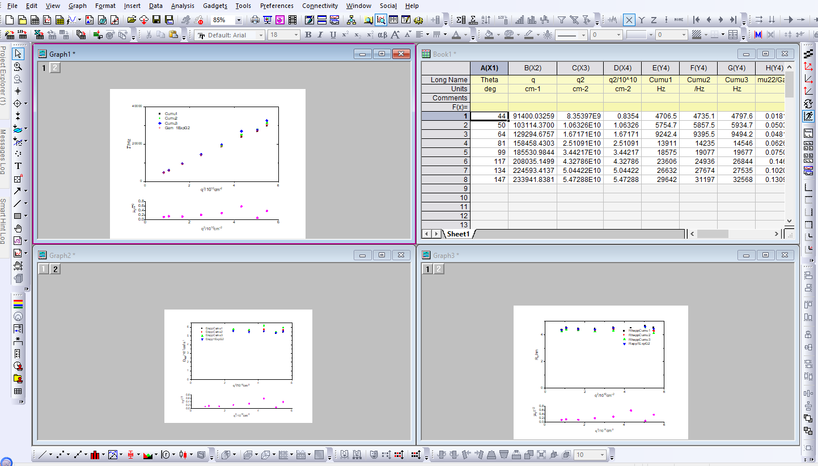

Make minor adjustments and do Origin fits, as appropriate. Unlike Trendline in Excel, you will see uncertainty estimates (you could use Linest or DataAnalysis Toolpak in Excel to do the same, but it is hard to make Excel plots pretty). Cut and paste to whatever document you want. (I find alt-E-G is the best way to cut in Origin; that’s one of their old shortcuts, and it seems more reliable that the usual right-click🡪copy).



This particular plot for 2nd-order cumulant is as expected for a simple, small diffuser: zero intercept within error, small uncertainties, high linear correlation coefficient. The 1EXP plot should be even better, if anything.

As expected the Rh vs q2 plot, which derives from the  vs q2 plot, is nearly flat with a low correlation coefficient.



There would be no reason to run CONTIN (regularized fit) program in the case of these data, but if you do, some information about that is found in the Appendix. You will be able to plot Rh,contin vs q2 in the same way using routine Size vs q2 from ALV Contin.xls. That routine is actually embedded in this Word Document (not in a .PDF derived from it).



Here’s a screenshot.

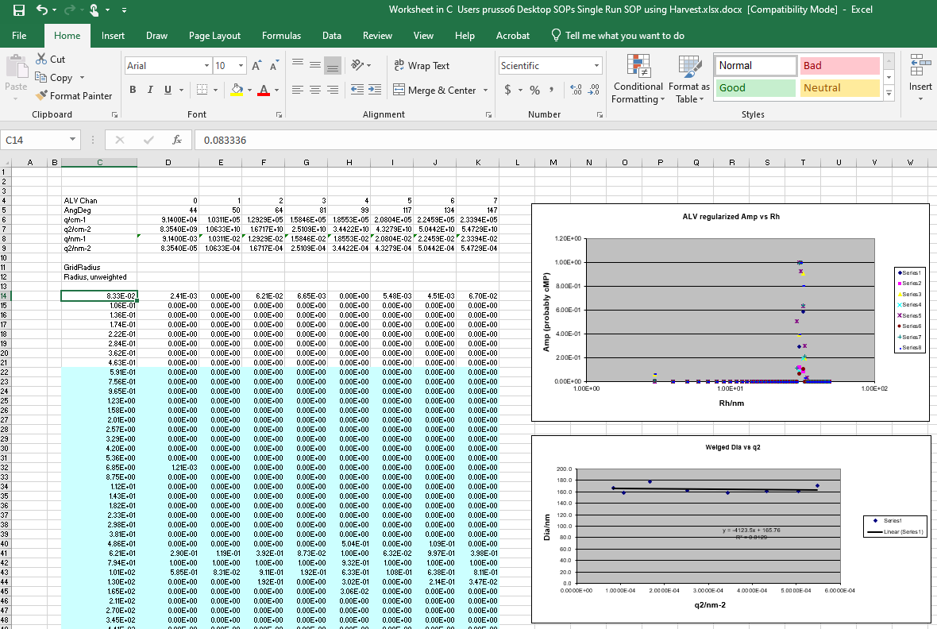

Appendix. Stuff from an SOP that predates the rebuild (so colors of channels are different, and some angles are too). This provides another look at the nonlinear fits and shows how to export the CONTIN data.

>>NonLinear Fits: 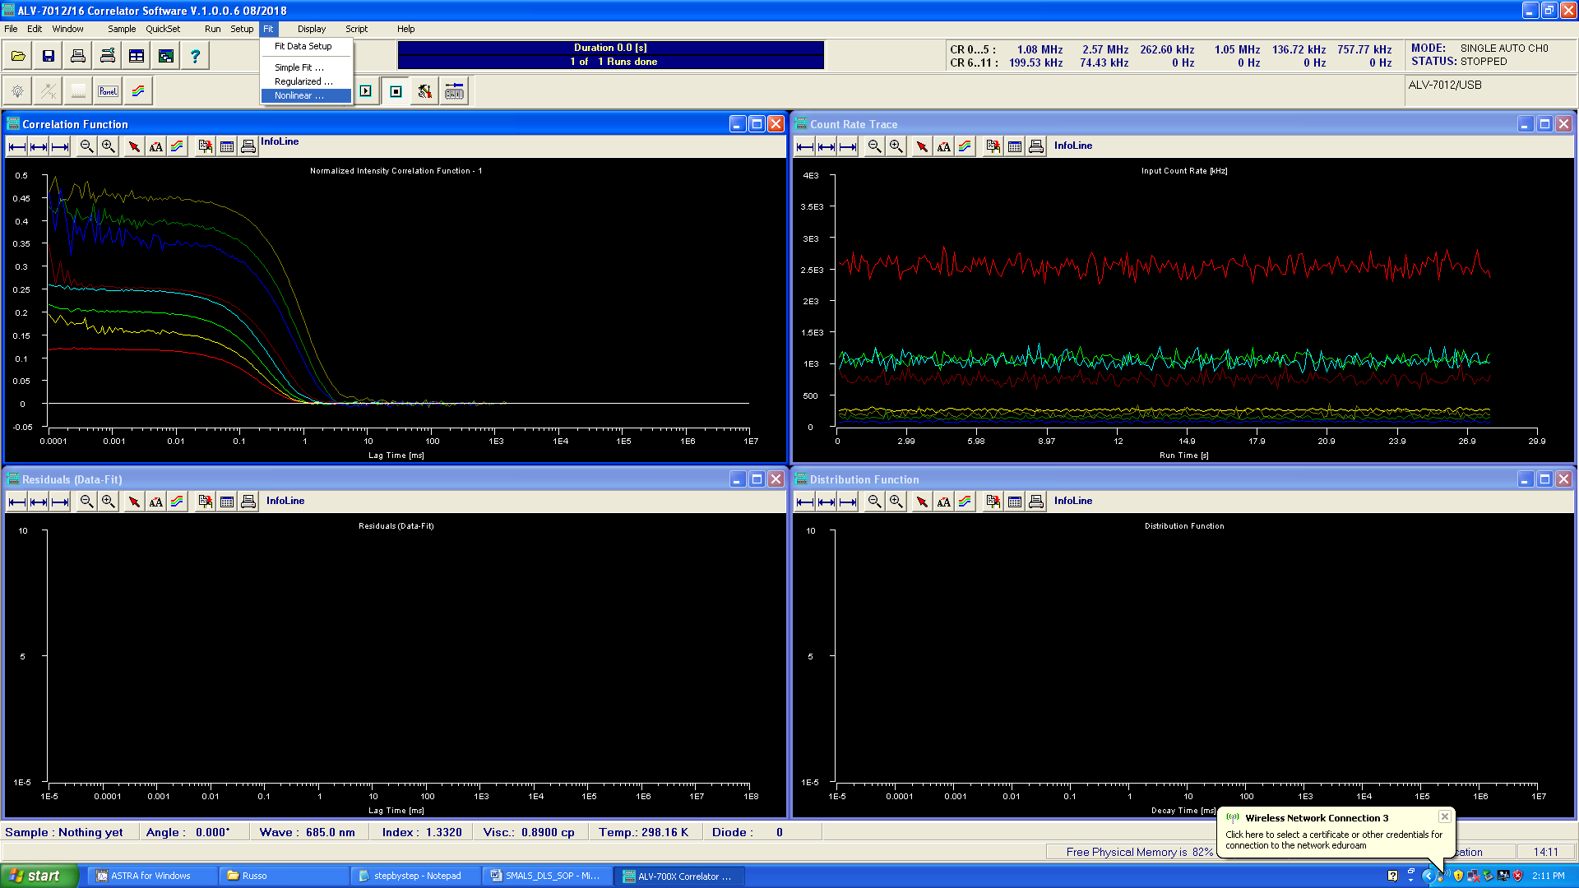

>>>Clear the results box

Be sure to ignore first 5 channels (approximately). Be sure the baseline is floating (a(0) not fixed). Select a channel, D0 to D7.

Click Do Fit

Inspect residuals (lower left panel)

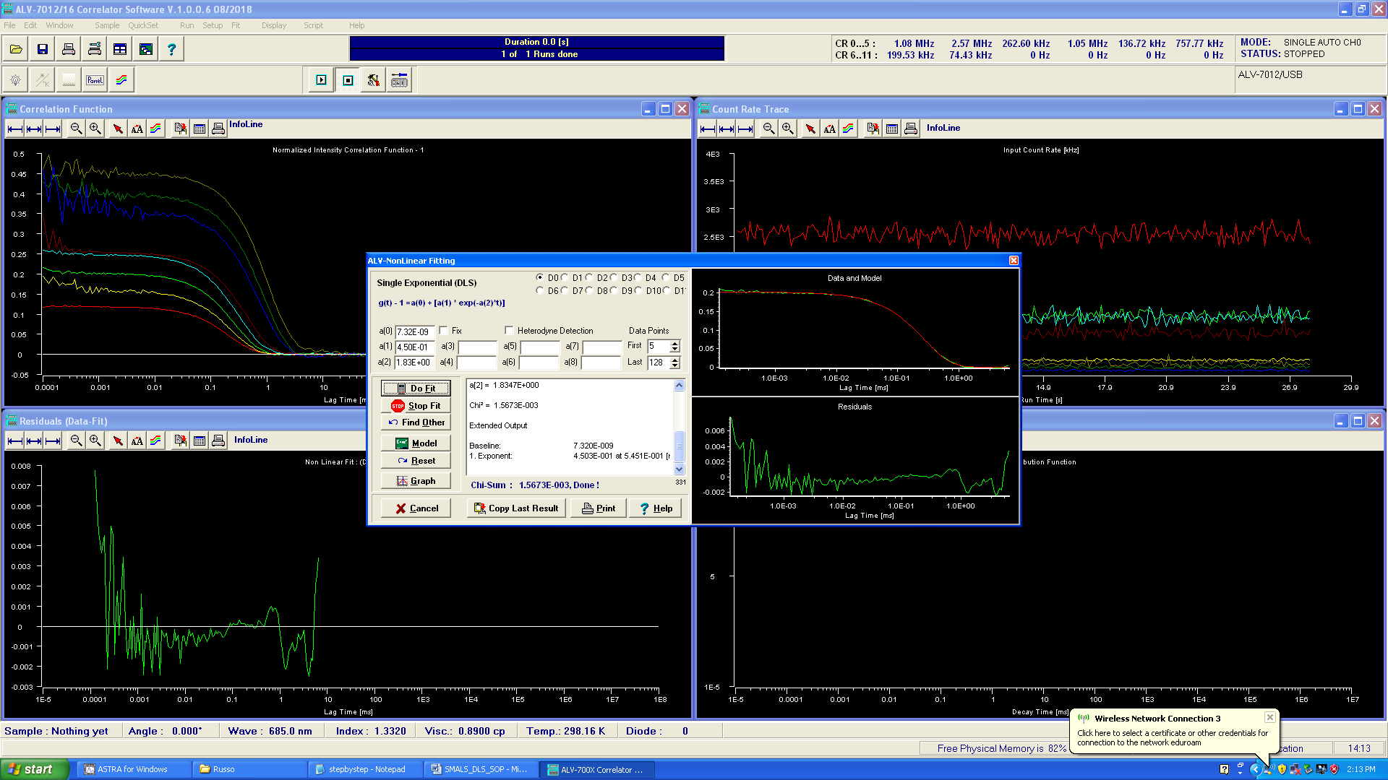

>>>do each channel one at a time.

(There has to be a script that lets you do them all at once and save)

>>>Mark all the results & copy to your saved file

Typical save output from Copy Last Result:

4.50268E-001 1.83467E+000 7.32015E-009

>>>Copy the residuals to Clipboard

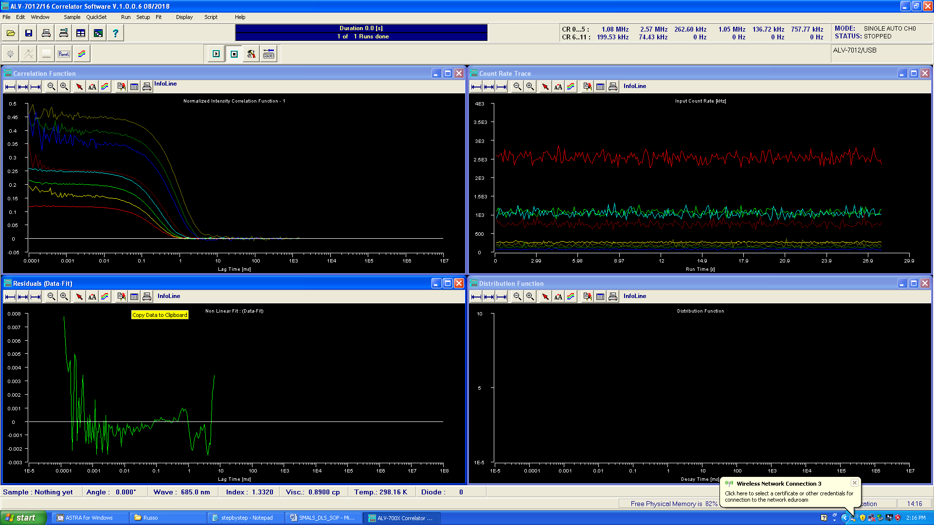

>>>Type Residuals in your saved file

>>>Carriage Return in saved file

>>>Paste clipboard contents to saved file

>>Regularized Fit

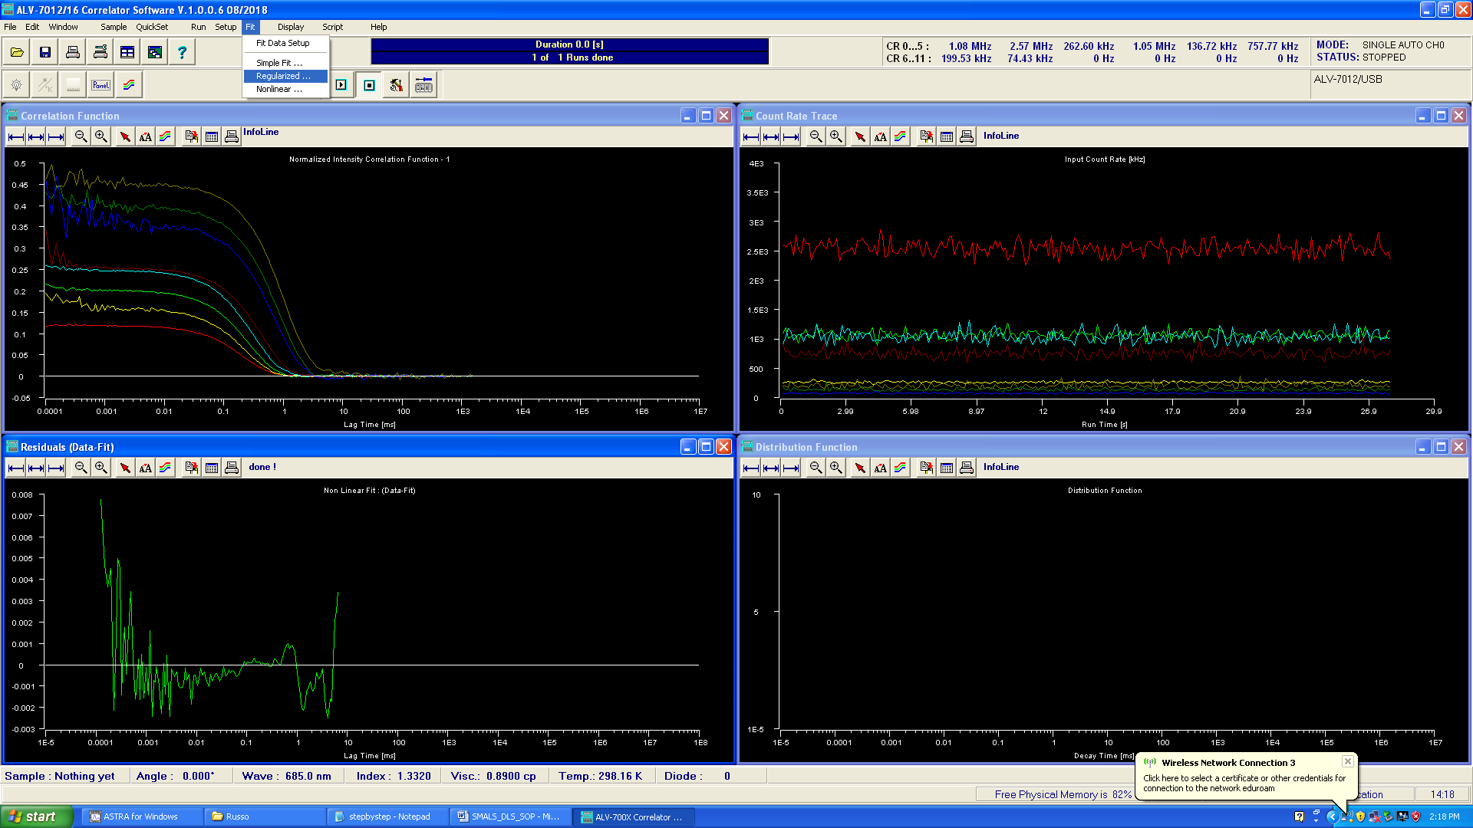

Adjust parameters (this requires expert level instruction)

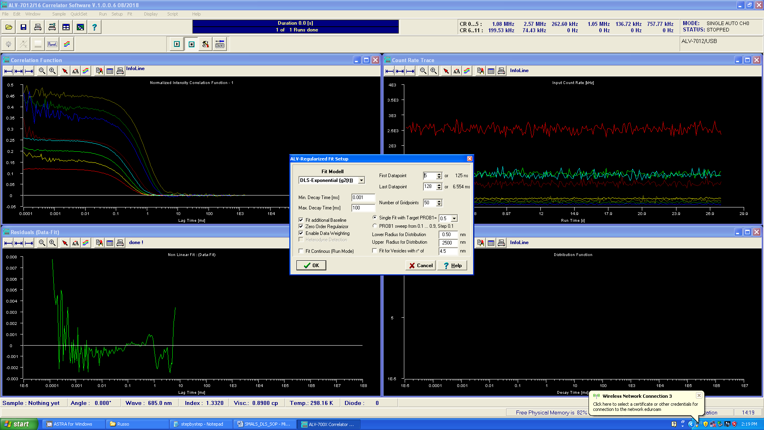

Output looks more or less like this:

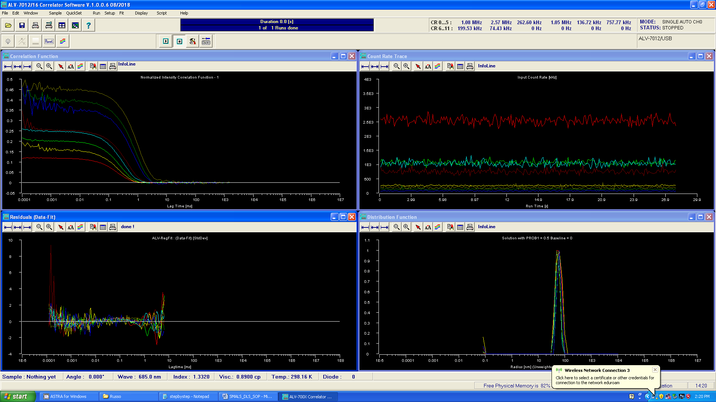

Copy Radius Results to clipboard

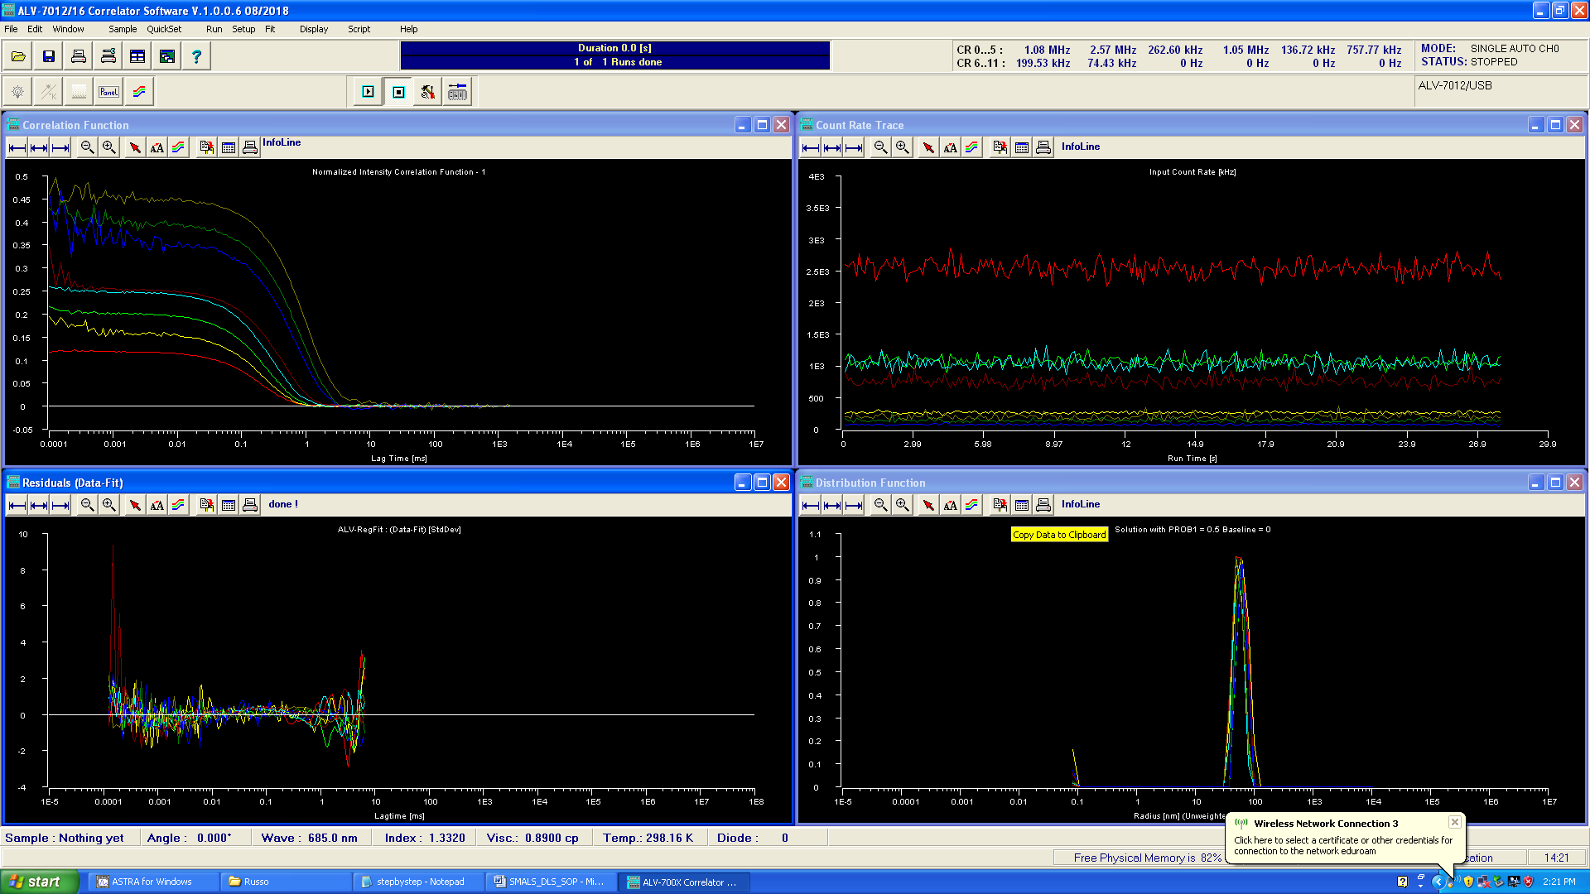

Type “Apparent Radius” into your saved file.

Paste Clipboard contents into your saved file

Type “Residuals” into your saved file

Carriage Return in saved file

Copy Residuals to clipboard

Paste the residuals (which seem to be incomplete) to your saved file.